**Marc Gavriele M. Esteban Bsit 305**

In this is that I created this website because I like pets but specially cat and so that they can be treated with care and respect so that they can be healthy and live longer I created a cat clinic for cats owners and anyone can use this ranging to kids to adults who has a cat. This site can be accessed everywhere you want from smart phone’s to desktop so that anytime you can help your little kitty.

This is the home screen or home page of the website in consists of every thing that you need to navigate the website

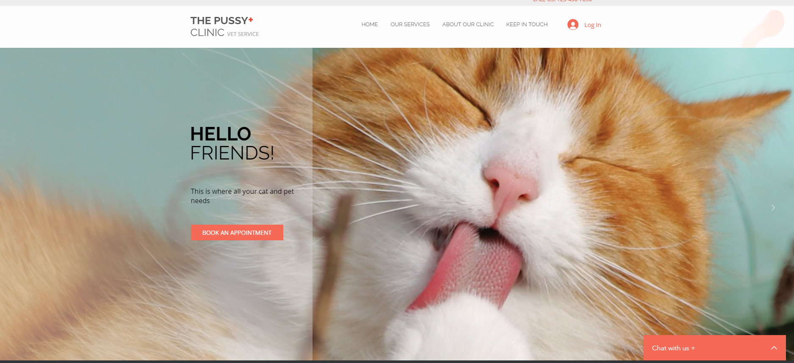

This is the service page which contains the services that the clinic offers.



In this is the about page and also the how to contact us page which has the about our clinic information and the location and contact number so that you or they can reach us if there is anything wrong or want to ask some information.

